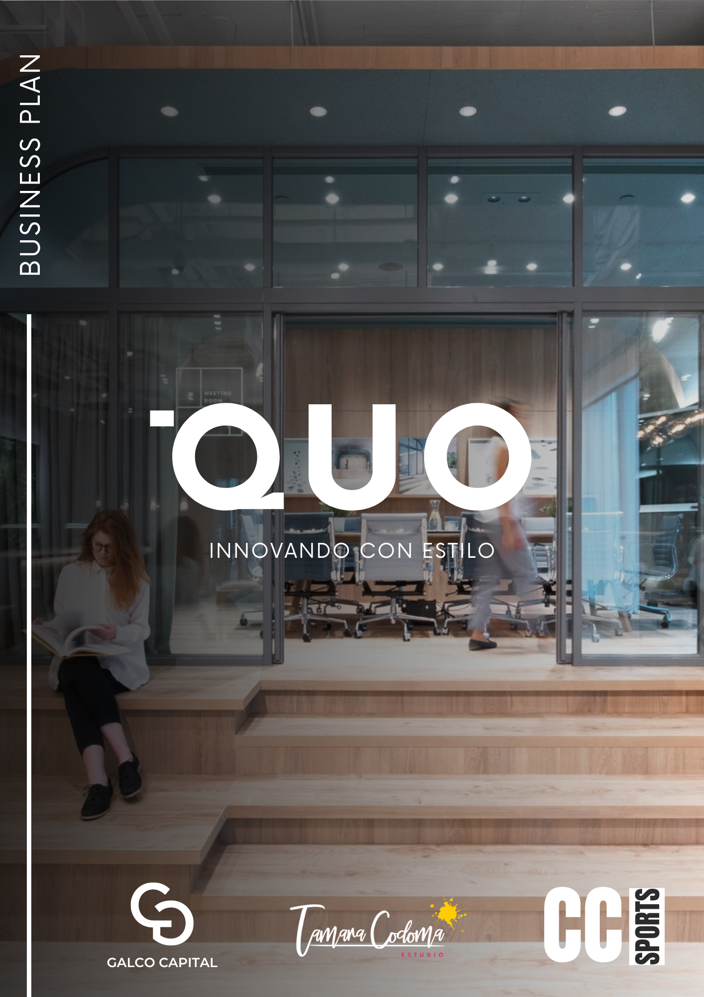

Executive Summary
Business Overview
Our business consists of the creation of a multifunctional and covered shopping center, which is distinguished by integrating four key services in the same space: a co-working area, a cafeteria-bar, a feminine beauty space and a yoga studio. The combination of these elements seeks to satisfy the diverse needs of our clientele, offering a versatile and attractive environment that encourages productivity, well-being and socialization.
Concept and Design
The shopping center will be characterized by a minimalist and bright design, with large, well-lit spaces that promote an atmosphere of tranquility and comfort. This approach not only improves the user experience, but also maximizes the functionality of the space, allowing for a seamless transition between different areas.
Business Model
Our business model is based on three fundamental pillars:
- Rental of Spaces to Third Parties: The center spaces will be rented to third parties, allowing efficient and diversified management of the services offered. This includes both the co-working area and the cafe-bar, the female beauty space and the yoga studio.
- Administration and Supply: We will be in charge of fiscal administration and supply of inputs for all businesses operating within the center. This centralized management will ensure a coherent and efficient operation, reducing costs and improving service quality.
- Monthly Subscription for Co-working: We will offer a monthly subscription to access the co-working space, providing different plans that adapt to the needs of freelancers, small businesses and growing work teams.
Cafeteria Offer
The cafeteria-bar will be distinguished by a varied offer adaptable to different times of the day, from healthy breakfasts and light lunches to drinks and snacks for the afternoon. This flexibility will allow it to attract a wide range of clients, from professionals looking for a place to work to visitors looking to relax and socialize.

Aim
Our goal is to create a dynamic and multifunctional space that becomes a point of reference in the community, offering high quality services and fostering an environment of collaboration and well-being.
With an innovative approach and efficient management, our shopping center has the potential to redefine the shopping and work experience, attracting a diverse and loyal clientele. The combination of co-working, cafe-bar, beauty space and yoga studio in a harmonious and well-designed environment promises to not only meet, but exceed the expectations of our clients.
Market Analysis
Market Trends
- Increase in Remote Work: The COVID-19 pandemic has accelerated the adoption of remote work, establishing a new normal in many industries. Companies of all sizes are implementing flexible work policies, which has significantly increased demand for co-working spaces. These spaces provide an ideal solution for freelancers, small businesses and remote teams looking for a professional environment without the costs associated with a traditional office.
- Wellbeing and Health: Awareness about the importance of well-being and health is on the rise. People are investing more time and resources in activities that promote their physical and mental well-being. Yoga studios and beauty services are sectors that have seen a steady increase in demand as they offer effective ways to reduce stress and improve quality of life. This growing interest in self-care is reflected in the proliferation of establishments dedicated to these activities in urban areas.
- Varied Gastronomy: Today's consumers seek unique and varied gastronomic experiences. This trend is manifested in the popularity of cafes and bars that offer diversified menus, adapted to different times of the day and that include healthy, vegan and gourmet options. The demand for culinary offerings that not only satisfy hunger, but also provide a sensory and social experience, is driving innovation in the restaurant sector.
Competition Analysis
In the market analysis, it is essential to consider the existing competition in each of the segments that make up our shopping center:
- Co-working spaces: Major competitors include international co-working chains like WeWork, as well as local independent spaces. Our focus on integrating multiple services under one roof and offering flexible monthly subscriptions will differentiate us by providing significant added value.
- Yoga Studios and Beauty Spaces: There are numerous yoga studios and beauty salons, but few offer the convenience of being in a multifunctional environment. Our value proposition lies in the synergy between physical and mental well-being, allowing clients to easily access both services in one place.
- Cafes and Bars: Competition in this sector is intense, with numerous options available to consumers. However, our focus on a varied and adaptable gastronomic offer, together with the creation of a welcoming and minimalist environment, will allow us to capture a niche market interested in differentiated culinary experiences.
Market analysis reveals that our shopping center is well positioned to take advantage of emerging trends. Demand for co-working spaces is on the rise due to remote working, while interest in wellness and health is driving the need for yoga studios and beauty services. At the same time, the pursuit of varied dining experiences offers a significant opportunity for our café-bar. The combination of these elements in a carefully designed environment allows us to meet the changing needs of urban consumers, positioning us as a preferred destination for work, wellness and socialization.
Market segment
Our multi-functional shopping center targets four main market segments, each with specific needs and wants that our business is designed to satisfy.
- Independent Professionals and Remote Workers:
  - Profile: Freelancers, entrepreneurs, small businesses and employees of companies that adopt remote work policies.
  - Needs: Flexible, well-equipped and professional work spaces that offer the necessary infrastructure to carry out your work efficiently.
  - Preferences: Quiet environments, access to additional services (cafeteria, meeting rooms), monthly subscriptions that allow them to manage their costs effectively.
  - Value Proposition: A co-working area with flexible and accessible plans, equipped with cutting-edge technology, collaboration spaces and private rooms, all in a modern and stimulating environment.
- Women Interested in Beauty Services:
  - Profile: Women of different ages and lifestyles looking for high-quality beauty services.
  - Needs: Convenient, quality beauty services, from facial and body treatments to hair and nail salons.
  - Preferences: Convenient location, comprehensive services in one place, relaxing atmosphere and professionalism of the staff.
  - Value Proposition: A feminine beauty space that offers a wide range of services, highly trained staff and high quality products, all in a pleasant and accessible environment.
- Wellness Enthusiasts:
  - Profile: People who value a healthy lifestyle and are committed to their physical and mental well-being.
  - Needs: Access to quality yoga classes, certified instructors, and an environment that encourages relaxation and personal improvement.
  - Preferences: Varied yoga programs (different styles and levels), flexible schedules, and an environment that complements its focus on comprehensive well-being.
  - Value Proposition: A yoga studio that offers a diversity of classes, flexible schedules, and an environment conducive to meditation and personal growth, all integrated into a multifunctional space.
- Gastronomy Lovers:
  - Profile: People who enjoy exploring different culinary experiences and value quality and variety in the gastronomic offer.
  - Needs: Varied menus to suit different times of the day and dietary preferences (including healthy and gourmet options).
  - Preferences: Cozy and stylish atmosphere, consistent quality of food and drinks, and excellent service.
  - Value Proposition: A cafeteria-bar that offers a diverse culinary experience adapted to different times of the day, with options that satisfy everything from a healthy breakfast to a light dinner, all in an attractive and modern environment.
By understanding and segmenting our market, we can design specific strategies for each group, ensuring our offerings align with their needs and preferences. This segmentation allows us not only to attract a diverse clientele, but also to create a space that becomes a point of reference for professionals, wellness enthusiasts, lovers of beauty and gastronomy. Our comprehensive, multifunctional approach uniquely positions us to meet the changing demands of the modern urban consumer.
Value Proposition
Our value proposition focuses on the creation of a multifunctional space that offers a unique and high-quality experience to our clients. Each component of our shopping center has been designed to meet the specific needs of our different market segments, guaranteeing a coherent and attractive offer.
Co-Working:
- Modern and Minimalist Spaces: We provide a work environment that combines modern and minimalist design, promoting productivity and creativity. The spaces are designed to maximize comfort and efficiency, with open areas that encourage collaboration and private zones for focused work.
- High Quality Technological Equipment: Our co-working spaces are equipped with cutting-edge technology, including high-speed internet connection, ergonomic workstations, meeting rooms with video conferencing equipment, and access to state-of-the-art printers and scanners.
- Flexibility in Monthly Subscription: We offer a variety of subscription plans to suit the needs of different users, from freelancers to small businesses. Flexible options allow customers to choose the plan that best suits their needs and budget, providing access to all the services and amenities of the co-working space.
Cafeteria-Bar:
- Varied Menu that Adapts to Different Times of the Day: Our café-bar features a diverse and adaptable menu, designed to meet the needs of our customers throughout the day. We offer everything from nutritious breakfasts and light lunches to dinners and snacks, guaranteeing an attractive offer at all times.
- Fresh and High Quality Ingredients: We use fresh, high-quality ingredients in all our preparations, ensuring a healthy and delicious dining experience. Our commitment to quality is reflected in every dish and drink we serve.
- Cozy and Modern Environment: The design of our cafe-bar combines comfort and modernity, creating a welcoming space where customers can relax, socialize and enjoy a good meal. The environment is designed to be attractive to both workers and occasional visitors.
Beauty Space:
- Comprehensive Personal Care Services: We offer a wide range of beauty services including facials, body treatments, hair and manicures, all in one place. This allows our customers to enjoy a complete and convenient personal care experience.
- Qualified Professionals: We have a team of highly qualified professionals with experience in the beauty sector. Our staff is committed to providing exceptional, personalized service, ensuring that each client receives the best treatment possible.
Yoga Studio:
- Classes Led by Certified Instructors: Our yoga studio offers classes taught by certified and experienced instructors, ensuring a safe and effective practice. Instructors are trained to guide participants of all levels, from beginner to advanced.
- Relaxing and Conducive Environment for Meditation and Exercise: The yoga studio has been designed to create a calm and relaxing environment, ideal for meditation and yoga practice. The spaces are carefully conditioned to encourage relaxation and well-being, offering a holistic experience that benefits both body and mind.
Our value proposition is based on offering a high-quality multifunctional environment that meets the diverse needs of our clients. From professionals looking for a flexible and well-equipped workspace, to people interested in well-being, beauty and gastronomy, our shopping center is designed to offer a comprehensive and satisfying experience. The combination of these services in one place allows us to stand out in the market and attract a varied and loyal clientele.
Competition Analysis
Our multifunctional shopping center faces competition in several sectors, each with its own key players and market dynamics. Below is a detailed competitive analysis for each of the components of our business, highlighting the strategies we will adopt to differentiate ourselves and offer added value to our clients.
- Co-Workings Locales:
  - Analysis of Service Offering and Prices: Local co-working spaces vary in terms of services and prices. Some offer daily, weekly and monthly rates, while others provide additional services such as meeting rooms, networking events and workshops. The analysis of these competitors allows us to identify areas of improvement and opportunities to differentiate ourselves.
  - Differentiation Strategy:
    - Added Value: Our co-working will differentiate itself by offering access to complementary services such as the yoga studio and beauty space. This integration not only improves the user experience but also promotes a balanced lifestyle.
    - Flexible Subscriptions: We will offer flexible monthly subscription plans that allow users to choose the level of access that best suits their needs, including options that combine the use of co-working with yoga classes and beauty services.
- Local Cafes and Bars:
  - Competition Analysis: Local cafes and bars often compete based on the quality of their products, atmosphere, and customer service. Some specialize in certain types of cuisine or drinks, while others stand out for their cozy atmosphere or strategic location.
  - Differentiation Strategy:
    - Differentiated Menu: Our cafeteria-bar will offer a varied and adaptable menu that is distinguished by the use of fresh, high-quality ingredients. Additionally, we will incorporate healthy and gourmet options that adapt to different times of the day, attracting a diverse clientele.
    - Attractive Environment: The modern and welcoming design of our café-bar will provide a pleasant space for customers to work, relax and socialise. Combining an attractive environment with excellent customer service will allow us to stand out in the local market.
- Beauty Salons and Yoga Studios:
  - Competition Analysis: Local beauty salons and yoga studios offer a variety of services, from basic treatments to specialized wellness programs. Competition in this sector often focuses on quality of service, staff experience, and location convenience.
  - Differentiation Strategy:
    - Service Integration: Our shopping center will integrate all services in one place, offering unmatched convenience for customers. The possibility of accessing beauty services and yoga classes within the same space where they work or socialize adds significant value to our proposal.
    - Qualified Professionals and Relaxing Environment: Both the beauty space and the yoga studio will have highly qualified professionals and an environment designed for relaxation and well-being. This ensures a high-quality experience that meets the expectations of the most demanding customers.
The competitive analysis reveals that, although there are numerous players in each of the segments that will make up our shopping center, we have the opportunity to significantly differentiate ourselves by offering a multifunctional space that integrates high-quality complementary services. By focusing on flexibility, quality and convenience, we are able to attract and retain a diverse clientele, establishing our shopping center as a preferred destination in the community.
Plan the Marketing
1. Launch Strategy:
To kick off our project with an impact, we have designed a launch strategy that involves a combination of exclusive events, irresistible promotions and a strong digital presence.
- Opening Events: We are committed to offering the community an unforgettable experience from day one. To do this, we are organizing free trial days where anyone can immerse themselves in the energy and warmth of our space. Additionally, we are excited to offer free yoga classes so everyone can feel the benefits of physical and mental relaxation and connection.
- Special Promotions: We want to make the idea of ​​joining our community irresistible. That's why we're launching exclusive discounts on our monthly co-working subscriptions and bundled service packages. We believe these special offers will help more people join our family from the beginning.
- Marketing Digital: Recognizing the importance of the digital world in modern life, we have designed strategic campaigns on social networks and Google Ads. Our focus will be on highlighting the convenience and variety of services we offer. We want our audience to know that we are much more than just a shared workspace; We are a destination where creativity, collaboration and growth meet.
- Influencers Locales: Recognizing the power of influence in the age of social media, we are looking to collaborate with local influencers, from artists to entrepreneurs, who have a strong follower base on platforms like Instagram. We believe these partnerships will help us reach new audiences authentically and effectively.
2. Continuous Strategies:
Our commitment to excellence and customer satisfaction does not end at launch. We have solid plans to stay relevant and exciting in the market for the long term.
- Customer Loyalty: We deeply value our members and want to reward their loyalty. That's why we're rolling out membership programs that offer a variety of exclusive benefits, from discounts on services to priority access to special events. In addition, we are encouraging the recommendation of new members with exclusive discounts for referrals.
- Regular Events: We believe in the importance of community and collaboration. That's why we plan to host a series of regular events, ranging from happy hours to workshops and seminars in our co-working space. These activities not only promote connection between our members, but also encourage learning and personal and professional growth.
- Collaborations: We recognize the value of partnering with other local businesses that share our values ​​and goals. We are actively seeking collaborations with companies in the wellness and beauty sector, as well as influencers who can enrich our offering and expand our influence in the community. Together, we believe we can reach new heights and create truly exceptional experiences for our customers.

Operational Plan
1. Location:
Our location is a fundamental part of our operational strategy. We are located in a covered space in a central and easily accessible area. This strategic location allows us to be accessible to our potential clients and members, making it easier for them to participate in our activities and services. Additionally, being in a central area, we are surrounded by a vibrant community that offers opportunities for collaboration and growth.
2. Design and Furniture:
The design and furnishings of our space are key elements in creating a welcoming and productive experience for our clients and members. We opt for a minimalist approach that encourages mental clarity and concentration. Our furniture is functional and ergonomic, designed to promote comfort and well-being during long working hours. Additionally, we have integrated natural and artificial lighting that creates a bright and stimulating environment, contributing to a positive and energizing work atmosphere.
3. Suppliers:
To ensure quality and excellence in our services, we partner with trusted local suppliers who share our values ​​of quality and sustainability.
- Cafeteria: We work with local suppliers who offer fresh, quality ingredients for our cafeteria. We are committed to offering our customers an exceptional dining experience, with healthy and delicious options that complement their active and productive lifestyle.
- Beauty and Yoga Services: We collaborate with high quality equipment and products for our beauty and yoga services. Our clients deserve the best, and we make sure to offer them treatments and classes that improve their physical and mental well-being. We work with qualified and passionate professionals who share our vision of promoting health and well-being in our community.
With these operational aspects carefully planned, we are confident that we can deliver an exceptional experience to our customers and members. We are committed to excellence in every detail and eager to realize our vision of an innovative and vibrant work and wellness space.

Management and Organizational Structure
1. Management Team:
Our management team is comprised of highly trained and passionate professionals, each playing a critical role in the success and growth of our business.
- CEO (Executive Director): Our CEO is the visionary leader behind our company. He is responsible for establishing the overall vision and strategy that guides our operations. With a combination of creativity, experience and long-term vision, the CEO leads the way toward achieving our goals and realizing our mission.
- Operations Manager: This team member is responsible for overseeing the day-to-day management of our operations. From managing human resources to optimizing processes and ensuring customer satisfaction, the operations manager plays a crucial role in the efficiency and effectiveness of our company.
- Gerente de Marketing: Our marketing manager is responsible for developing and implementing effective promotion and customer acquisition strategies. From planning advertising campaigns to analyzing data and maintaining a strong online presence, this team member works tirelessly to increase the visibility and recognition of our brand.
- Finance Administrator: This role is essential to ensure the financial stability and sustainable growth of our company. The finance manager is responsible for managing accounts, managing budgets, and managing relationships with suppliers and financial partners. Their experience and precision ensure that our operations remain financially sound at all times.

2. Personal:
Our staff team is made up of talented and dedicated individuals who play essential roles in delivering exceptional services to our clients.
- Baristas and Kitchen Staff: Our team of baristas and kitchen staff are responsible for providing our customers with an exceptional dining experience. From preparing delicious drinks to creating tempting dishes, their attention to detail and passion for excellence ensure that every visit to our café is memorable.
- Stylists and Beauty Technicians: Our team of stylists and beauty technicians are talented professionals dedicated to enhancing the beauty and well-being of our clients. With expert skills and high-quality products, they offer a wide range of beauty and personal care services that meet each client's individual needs and desires.
- Yoga Instructors: Our yoga instructors are certified teachers who share their passion for physical and mental well-being with our clients. With a focus on technique, breathing, and the mind-body connection, they guide participants through classes that promote strength, flexibility, and relaxation. Her commitment to teaching and individual care ensures that each yoga session is an enriching and rejuvenating experience.
With a strong management team and dedicated staff, we are poised to achieve new levels of success and excellence in delivering quality services to our community.

Financial Plan
1. Initial Costs:
Our startup costs are intended to establish a solid foundation for our business and ensure a successful launch.
- Rental and Adaptation of Space: 50,000€. This cost includes the rental of the space and the expenses associated with adapting and customizing it to meet our operational and aesthetic needs.
- Furniture and Equipment: 30,000€. We will invest in quality furniture and modern equipment that provides comfort and functionality to our customers and employees.
- Initial Marketing: 10,000€. We will allocate funds to launch an effective initial marketing campaign that raises awareness of our brand and attracts potential customers from the beginning.
- Initial Operating Costs (3 months): 20,000€. These costs will cover operating expenses such as staff salaries, supplies and other recurring expenses during the first three months of operation.
2. Projected Revenue:
Our income will come from various sources that reflect the diversity of services we offer:
- Co-working Subscriptions.
- Daily Sales of the Cafeteria-Bar.
- Rental of Beauty and Yoga Spaces.
- Events and Workshops.
3. Balance Sheet Projection:
- Expected Monthly Income: 25,000€. Based on our projections of income from various sources, we expect to generate a monthly income of 25,000€.
- Monthly Operating Expenses: 15,000€. This includes costs such as staff salaries, rent, supplies, ongoing marketing, and other recurring operating expenses.
- Monthly Net Profit: 10,000€. After deducting our operating expenses from our projected monthly revenue, we anticipate a monthly net profit of 10,000€.
With this financial projection, we are confident in our ability to operate profitably and sustainably over the long term. We are committed to responsible financial management and are prepared to adapt and adjust our strategy as necessary to ensure the continued success of our business.
Conclusion
In short, our open indoor shopping center represents an exciting business opportunity that capitalizes on current market trends and offers a unique and engaging experience for our community. With a clear value proposition and an effective marketing strategy, we are well positioned to attract a diverse and loyal clientele.
Our focus on diversifying services, which includes co-working areas, cafe-bar, beauty and yoga spaces, as well as events and workshops, differentiates us from the competition and allows us to satisfy the diverse needs and desires of our clients.
Through a combination of carefully calculated initial investment, strong projected revenue and prudent financial management, we are confident we can achieve a profitable and sustainable business over the long term. We are committed to excellence in every aspect of our operation and are excited to begin this journey toward business success.
In short, our goal is to become a reference destination in our community, where innovation, creativity and well-being merge to create a unique and enriching experience for all our clients. We are ready to make this vision a reality and look forward to the exciting journey ahead. Join us on this exciting adventure!

